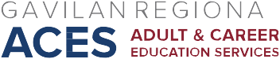

AB 104 Consortium Workshop Meeting
November 4, 2016
Agenda

- Updates/Announcements
- AEBG Summit
- ALLIES
- Vision Literacy
- Community for Accredited Online Schools
- Other

- Data Collection/Use of monies
III Pathways Visual review

Next Meeting: Friday, November 18, 2016, HRC 101

